**Archibald First School**



How we teach calculations:

**Mathematics**

About our Calculation Policy

The following calculation policy has been devised to meet requirements of the National Curriculum 2014 for the teaching and learning of mathematics, and is also designed to give pupils a consistent and smooth progression of learning in calculations across the school. Please note that early learning in num-

ber and calculation in Reception follows the Development Matters‟ EYFS document, and this

calculation policy is designed to build on progressively from the content and methods established in

the Early Years Foundation Stage. The inclusion of year 5 expectations is to meet the needs of our more able mathematicians

**Age related expectations**

The calculation policy is organised according to age stage expectations as set out in the National Curriculum 2014, **however it is vital that pupils are taught according to the stage that they are currently working at,** being extended within their level (or moving to the next level when sufficient challenge at their current level has been given), or working at a lower stage until they are secure enough to move on.

**Using and applying:**

It is important that any type of calculation is given a real life context or problem solving approach to help build children’s understanding of the purpose of calculation, and to help them recognise when to use certain operations and methods when faced with problems. This should be a priority within calculation and problem solving lessons.

**Choosing a calculation method:**

Children need to be taught and encouraged to use the following processes in deciding what approach they will take to a calculation, to ensure they select the most appropriate method for the numbers involved:

Can I do it in my head using a

mental strategy?

Could I use some jottings to

help me?

Should I use a written

method to work it out?

|  |
| --- |
| To work out a tricky calculation: |
| Estimate, |
| Calculate, |
| Check it! |

**Year 1 Add with numbers up to 20**



Numbers are written alongside one another and the “skipping ropes” indicates which part of the number is to be added together (the units and tens)

14 + 13 = 27

# 20 7

Before children are ready for this method they will have had a wide range of experiences including:

* Have access to a wide range of counting equipment, everyday objects, number tracks and number lines, and be shown numbers in different con- texts.
* Be given the opportunity to add on a number square (adding units then 10s.

**Children should also:**

* + Read and write the addition (+) and equals (=) signs within number sentences.
  + Interpret addition number sentences and solve missing box problems, using concrete objects and number line addition to solve them: 8 + 3 = 15 + 4 = 5 + 3 + 1 = + = 6

This builds on from prior learning of adding by combining two sets of objects into one group (5 cubes and 3 cubes) in Early Years.

**Key vocabulary**: add, more, plus, and, make, altogether, total, equal to, equals, double, most, count on

**Key Skills for addition at Y1:**

* Read and write numbers to 100 in numerals, incl. 1—20 in words
* Recall bonds to 10 and 20, and addition facts within 20
* Count to and across 100
* Count in multiples of 1 2, 5 and 10
* Solve simple 1-step problems involving addition, using objects, number lines and pictorial representations.

**Year 2** Add with 2-digit numbers Developing mental fluency with addition and place value involving 2-digit numbers, then establish more formal methods.

Continue to use skipping rope method until children are secure and ready to move on.

Add pairs of 2-digit numbers, moving to the partitioned column method when secure adding tens and units:

**23 + 34: STEP 1:**Only provide

examples that do

23 = 20 + 3

+ 34 = 30 + 4

50 + 7 = 57

**NOT** cross the tens boundary until they are secure with the method itself.

**STEP 2:** Once children can add a multiple of ten to a 2-digit number mentally (e.g. 80+11), they are ready for adding pairs of

2-digit numbers that DO cross the tens boundary (e.g. 58 + 43).

**58 + 43**

58 = 50 + 8

+ 43 = 40 + 3

90 + 11 = 101

**STEP 3**: Children who are confident and accurate with this stage should move onto the expanded addition methods with 2 and 3-digit numbers (see Y3).



To support understanding, pupils may physically make and carry out the calculation with

Dienes Base 10 apparatus or place value counters, then compare their practical version to the written form, to help them to build an understanding of it.

**Key vocabulary**: add, more, plus, and, make, altogether, total, equal to, equals, double, most, count on, number line, sum, tens, units, partition, addition, column, tens boundary

Key Skills for addition at Y2: (those in BLUE do not need to be rapid recall)

* Add a 2-digit number and ones (e.g. 27 + 6)
* Add a 2-digit number and tens (e.g. 23 + 40)
* Add pairs of 2-digit numbers (e.g. 35 + 47)
* Add three single-digit numbers (e.g. 5 + 9 + 7)
* Show that adding can be done in any order (the commutative law).
* Recall bonds to 20 and bonds of tens to 100 (30 + 70 etc.)
* Count in steps of 2, 3 and 5 and count in tens from any number.
* Understand the place value of 2-digit numbers (tens and ones)
* Compare and order numbers to 100 using < > and = signs.
* Read and write numbers to at least 100 in numerals and words.
* Solve problems with addition, using concrete objects, pictorial representations, involving numbers,
* quantities and measures, and applying mental and written methods.

**Year 3** Add numbers with up to 3-digits

Introduce the **expanded column addition** method:

34

+ 25

9

50 59

Add the **units** first, in preparation for the compact method.

In order to carry out this method of addition:

* + Children need to recognise the value of the hundreds, tens and units without recording the partitioning.
  + Pupils need to be able to add in columns.

Move to the compact **column addition** method, with carrying

Children who are very secure and confident with 3-digit

Add **units** first.

Carry numbers **underneath** the bottom line.

236

# + 73

309

1

expanded column addition should be moved onto the **compact column addition** method, being introduced to carrying for the first time. Compare the expanded method to the compact column method to develop an understanding of the process and the reduced number of steps involved.

Remind pupils the actual value is „**three tens** add **seven**

**tens‘**, not **‗**three add seven‟, which equals **ten** tens.

**Key vocabulary**: add, more, plus, and, make, altogether, total, equal to, equals, double, most, count on, number line, sum, tens, units, partition, plus, addition, column, tens boundary, **hundreds boundary, increase, vertical, carry, expanded, compact**



**Key Skills for addition at Y3:**

* Read and write numbers to 1000 in numerals and words.
* Add 2-digit numbers mentally, incl. those exceeding 100.
* **Add a three-digit number and ones mentally (175 + 8)**
* **Add a three-digit number and tens mentally (249 + 50)**
* **Add a three-digit number and hundreds mentally (381 + 400)**
* Estimate answers to calculations, using inverse to check answers.
* Solve problems, including missing number problems, using
* number facts, place value, and more complex addition.
* Recognise place value of each digit in 3-digit numbers (hundreds, tens, ones.)
* Continue to practise a wide range of mental addition strategies, ie. number bonds, adding the nearest multiple of 10, 100, 100 and adjusting, using near doubles, partitioning and recombining.

**Year 4 Add numbers with up to 4 digits including decimals**

Move from expanded addition to the compact column method, **adding units**

**first**, and „carrying‟ numbers **underneath** the calculation. Also include money and measures contexts.

**e.g. 3517 + 396 = 3913**

3517

+ 396

3913

1 1

Introduce the **compact column addition** method by asking children to add the two given numbers to- gether using the method that they are familiar with (expanded column addition—see Y3). Teacher models the compact method with carrying, asking children to discuss similarities and differences and establish how it is carried out.

Add **units** first.

Carry numbers **underneath** the bottom line.

Reinforce correct place value by reminding them the actual value is 5 hundreds add 3 hun- dreds, **not 5 add 3**, for example.

Use and apply this method to money and measurement values.



**Key vocabulary**: add, more, plus, and, make, altogether, total, equal to, equals, double, most, count on, number line, sum, tens, units, partition, plus, addition, column, tens boundary, hundreds boundary, increase, vertical, carry, expanded, compact, **thousands, hundreds, digits, inverse**

**Key Skills for addition at Y4:**

* + Select most appropriate method: mental, jottings or written and explain why.
  + Recognise the place value of each digit in a four-digit number.
  + Round any number to the nearest 10, 100 or 1000.
  + Estimate and use inverse operations to check answers.
  + Solve 2-step problems in context, deciding which operations and methods to use and why.
  + Find 1000 more or less than a given number.
  + Continue to practise a wide range of mental addition strategies, ie. number bonds, add the nearest multiple of 10, 100, 1000 and adjust, use near doubles, partitioning and recombining.
  + Add numbers with up to 4 digits using the formal written method of column addition
  + Solve 2-step problems in contexts, deciding which operations and methods to use and why.

**Year 5 Add numbers with more than 4 digits and mixed decimals**

including money, measures and decimals with different numbers of decimal places.

£23.59

+ £ 7.55

£ 31.14

1 1 1

19 . 01

3 . 65

+ 0 . 70

23 . 36

1 1

Say 6 tenths add 7

The decimal point should be aligned in the same

way as the other place value columns, and must be in the same column in the answer.

Numbers should exceed 4 digits.

Pupils should be able to add more than two values, carefully aligning place value columns.

Empty decimal places can be filled with zero to show the place value in each column.

tenths‟ to reinforce place value.



**Children should:**

Understand the place value of **tenths and hundredths** and use this to align numbers with different numbers of decimal places.

**Key vocabulary**: add, more, plus, and, make, altogether, total, equal to, equals, double, most, count on, number line, sum, tens, units, partition, plus, addition, column, tens boundary, hundreds boundary, increase, carry, expanded, compact, vertical, thousands, hundreds, digits, inverse & **decimal places, decimal point, tenths, hundredths, thousandths**

**Key Skills for addition at Y5:**

* Add numbers mentally with increasingly large numbers, using and practising a range of mental strategies ie. add the nearest multiple of 10, 100, 100 and adjust; use near doubles, inverse, partitioning and

re-combining; using number bonds.

* Use rounding to check answers and accuracy.
* Solve multi-step problems in contexts, deciding which operations and methods to use and why.
* Read, write, order and compare numbers to at least 1 million and determine the value of each digit.
* Round any number up to 1 000 000 to the nearest 10, 100, 1000, 10 000 and 100 000.
* Add numbers with more than 4 digits using formal written method of columnar addition

**Year 1 Subtract from numbers up to 20**

Children consolidate understanding of subtraction practically, showing subtraction on bead strings, using cubes etc. and in familiar contexts, and are introduced to more formal recording using number lines as below:

Subtract by taking away

Read, write and interpret number sentences with

**-** and **=** signs.

**Count back** in ones on a numbered number line to take away, with numbers up to 20:

###### 10 – 3 = 7

1 1 1

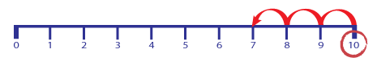

**Before children are ready for this method they will have had a wide range of experiences including:**

- Subtracting practically using the language – find the difference between, how many more and take away in a range of familiar contexts

- Be given the opportunity to subtract on a number square (subtracting units then 10s when ready).

**Children should also:**

* Interpret addition number sentences and solve missing box problems, using concrete objects and number line addition to solve them: 8 - 3 = 15 - 4 = 12 - =6

Mental subtraction

Children should start recalling subtraction facts up to **and within** 10 and 20, and should

|  |  |  |
| --- | --- | --- |
| be able to subtract zero. | | |
|  | **Key vocabulary**: equal to, take, take away, less, minus, subtract, leaves, distance between, how many more, how many fewer / less than, most, least, count back , how many left, how much less is_?  **Key Skills subtraction at Y1:**   * Given a number, say **one more or one less.** * Count to and over 100, **forward and back**, from any number. * Represent and use **subtraction facts to 20 and within 20**. * Subtract with **one-digit and two-digit** numbers to 20, including zero. * Solve one-step problems that involve addition and subtraction, using concrete objects (ie bead string, objects, cubes) and pictures, and missing number problems. |  |
|  | * Read and write numbers from 0 to 20 in numerals and words. |  |

**Year 2 Subtract with 2-digit numbers**

**Subtract on a number line by counting back**, aiming to develop mental subtraction skills.

This strategy will be used for:

Use Dienes blocks for subtraction calculations too.

* + **2-digit numbers subtract units** (by taking away / counting back) e.g. 36—7
  + **2-digit numbers subtract tens** (by taking away / counting back) e.g. 48—30
  + **Subtracting pairs of 2-digit numbers** (see below:)

Subtracting pairs of 2-digit numbers on a number line:

**47 - 23 = 24** Partition the second number and subtract it in tens and units, as below:

Move towards more efficient jumps back, as below:

20

1 1 1 1 10 10

23 27 37 47

**Subtract**

23 27 47

**Then subtract units.**

**tens first.** Combine methods with use of a

hundred square to reinforce

understanding of

number value and order.

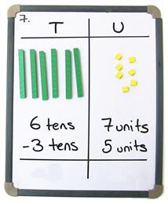

**Key vocabulary**: equal to, take, take away, less, minus, subtract, leaves, distance between, how many more, how many fewer / less than, most, least, count back , how many left, how much less is **difference, count on, strategy, partition, tens, units**

**Key skills for subtraction at Y2:**

* Recognise the place value of each digit in a two-digit number.
* Recall and use subtraction facts to 20 fluently, and derive and use related facts up to 100.
* Subtract using concrete objects, pictorial representations, 100 squares and mentally, including: a two- digit number and ones, a two-digit number and tens, and two two-digit numbers.
* Show that subtraction of one number from another cannot be done in any order.
* Recognise and use inverse relationship between addition and subtraction, using this to check calcula- tions and missing number problems.
* Solve simple addition and subtraction problems including measures, using concrete objects, pictorial representation, and also applying their increasing knowledge of mental and written methods.
* Read and write numbers to at least 100 in numerals and in words.

**Year 3** Subtracting with 2 and 3-digit numbers.

Introduce **partitioned column subtraction** method.

**STEP 1:** introduce this method with examples where **no exchanging** is required.

##### 89 – 35 = 54

80 + 9

**-** 30 + 5

#### 50 + 4

When learning to exchange, explore

„partitioning in different waysso that pupils understand that when you exchange, the **VALUE** is the same ie **72** = 70+2 = 60+12 = 50+22 etc. Emphasise that the **value hasn‘t changed**, we have just partitioned it in a different way.

60

**STEP 2:** introduce

„exchanging‟ (through practical subtraction if children need it. Make the . larger number with dienes, then subtract 47 from

it.)

60 70 + 2

**-** 40 + 7

#### 20 + 5 = **25**

238 – 146 = 92

**STEP 3:** Once pupils are secure with the understanding of exchanging, they can use the partitioned column method to subtract any 2 and 3-digit numbers.

100

#### 200 + 30 + 8

100 + 40 + 6

0 + 90 + 2 = 92

Subtracting money: partition into e.g.

£1 + 30p + 8p



**Counting on** as a mental strategy for subtraction:

Reinforce counting **on** as a strategy for **close-together numbers** (e.g. 121—118), and also for numbers that are nearly multiples of 10, 100, 1000 or £s, which make it easier to count on (e.g. 102-89, 131—79, or calculating change from £1 etc.).

Start at the smaller number and count on in **tens** first, then count on in units to find the rest of the difference:

**Key vocabulary**: equal to, take, take away, less, minus, subtract, leaves, distance between, how many more, how many fewer / less than, most, least, count back , how many left, how much less is_? difference, count on, strategy, partition, tens, units **exchange, decrease, hundreds, value, digit**

**Key skills for subtraction at Y3:**

* Subtract mentally a: **3-digit number and ones, 3-digit number and tens, 3-digit number and hundreds** .
* Estimate answers and use inverse operations to check.
* Solve problems, including missing number problems.
* Find 10 or 100 more or less than a given number.
* Recognise the place value of each digit in a 3-digit number .
* Read and write numbers up to 1000 in numerals and words.
* Practise mental subtraction strategies, such as subtracting near multiples of 10 and adjusting (e.g. subtracting 19 or 21), and select most appropriate methods to subtract, explaining why.

**Year 4 Subtract with up to 4-digit numbers**

Recap - Partitioned column subtraction with ‘exchanging’ (decomposition):

###### 2754 - 1562 = 1192

600

2000 + 700 + 50 + 4

1000 + 500 + 60 + 2

1000 + 100 + 90 + 2 = 1192

As introduced in Y3, but moving

towards more complex numbers and values. Use **place value coun- ters** to reinforce „exchanging‟.

Moving onto compact column subtraction Subtracting money: partition

into £1 + 30 + 5 for example.

6 1

#### 2754

- 1562

1192

To introduce the compact method, ask children to perform a subtraction calculation with the familiar partitioned column subtraction then display the compact version for the calculation they have done. Ask pupils to consider how it relates to the method they know, what is similar and what is different, to develop an understanding of it.

Give plenty of opportunities to apply this to money and measures.

Mental strategies

Always encourage children to consider the best method for the numbers involved— mental, counting on, counting back or writ- ten method



A variety of mental strategies must be taught and practised, including counting on to find the difference where numbers are closer together, or where it is easier to

count on (see video below). Approximate,

Calculate, Check it!

**Key vocabulary**: equal to, take, take away, less, minus, subtract, leaves, distance between, how many more, how many fewer / less than, most, least, count back , how many left, how much less is_? difference, count on, strategy, partition, tens, units exchange, decrease, hundreds, value, digit,**inverse**

**Key skills for subtraction at Y4:**

* Subtract by counting on where numbers are close together or they are near to multiples of 10, 100 etc.
* Children select the most appropriate and efficient methods for given subtraction calculations.
* Estimate and use inverse operations to check answers.
* Solve addition and subtraction 2-step problems, choosing which operations and methods to use and why.
* Solve simple measure and money problems involving fractions and decimals to two decimal places.
* Find 1000 more or less than a given number.
* Count backwards through zero, including negative numbers.
* Recognise place value of each digit in a 4-digit number Round any number to the nearest 10, 100 or 1000
* Solve number and practical problems that involve the above, with increasingly large positive numbers.

**Y**

**e**

**Year 5 Subtract with at least 4-digit numbers** (**including money, measures, decimals).**

###### Compact column subtraction

(with „exchanging‟).

Children who are still not secure with number facts and place value will need to remain on the partitioned column method until ready for the compact method.



Subtracting with larger integers.

7169 – 372.5 = 6796.5

1

7169.0

- 372.5

6796.5

Add a zero in any empty decimal places to aid understanding of what to subtract in that column.

Subtract with decimal values, including mixtures of integers and decimals, aligning the decimal point.

Create lots of opportunities for subtracting and finding differences with money and measures.

**Key vocabulary**: equal to, take, take away, less, minus, subtract, leaves, distance

between, how many more, how many fewer / less than, most, least, count back , how many left, how much less is_? difference, count on, strategy, partition, tens, units

exchange, decrease, hundreds, value, digit, inverse, **tenths, hundredths, decimal point, decimal**

**Key skills for subtraction at Y5:**

* Subtract numbers mentally with increasingly large numbers .
* Use rounding and estimation to check answers to calculations and determine, in a range of contexts, levels of accuracy .
* Solve addition and subtraction multi-step problems in context, deciding which operations and methods to use and why.
* Read, write, order and compare numbers to at least 1 million and determine the value of each digit.
* Count forwards or backwards in steps of powers of 10 for any given number up to 1 million.
* Interpret negative numbers in context, counting forwards and backwards with positive and negative in- tegers through 0.
* Round any number up to 1 million to the nearest 10, 100, 1000, 10 000 and 100 000.

**Year 1 Multiply with concrete objects, arrays and pictorial representations.**

How many legs will 3 teddies have?

There are 3 sweets in one bag. How many sweets are in 5 bags altogether?

3+3+3+3+3 = 15

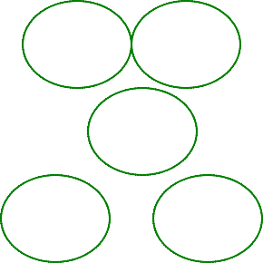

2 + 2 + 2 = 6

* + Give children experience of counting equal group of objects in 2s, 5s and 10s.
  + Present practical problem solving activities involving counting equal sets or groups, as above.

**Key vocabulary**: groups of, lots of, times, array, altogether, multiply, count

Key skills for multiplication at Y1:

Count in multiples of 2, 5 and 10.

Solve one-step problems involving multiplication, by calculating the answer using concrete objects, pictorial representations and arrays with the support of the teacher.

Make connections between arrays, number patterns, and counting in twos, fives and tens.

Begin to understand doubling using concrete objects and pictorial representations.

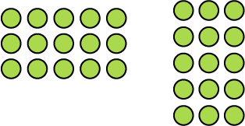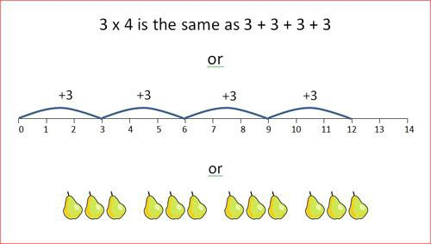

**Year 2 Multiply using arrays and repeated addition (using at least 2s, 5s and 10s)**

**Use repeated addition on a number line:**

Starting from zero, make equal jumps up on

a number line to work out multiplication facts

and write multiplication statements using x and = signs.

**#**

##### Use arrays:

**5 x 3** = 3 + 3 + 3 + 3 = **15**

**3 x 5** = 5 + 5 + 5 = **15**

Use arrays to help teach children to understand the commutative law of multiplication, and give examples such as **3 x = 6.**

**Use mental recall:**

* + - Children should begin to **recall multiplication facts for 2, 5 and 10** times tables through practice in counting and understanding of the operation.

**Key vocabulary:** groups of, lots of, times, array, altogether, multiply, count, multiplied by, repeated addition, column, row, commutative, sets of, equal groups, times as big as, once, twice, three times...

**Key skills for multiplication at Y2:**

* Count in steps of 2, 3 and 5 from zero, and in 10s from any number.
* Recall and use multiplication facts from the **2, 5 and 10** multiplication tables, including recognising odds and evens.
* Write and calculate number statements **using the x and = signs**.
* Show that multiplication can be done in any order (commutative).
* Solve a range of problems involving multiplication, using concrete objects, arrays, repeated addition, mental methods, and multiplication facts.
* Pupils use a variety of language to discuss and describe multiplication.

##### Year 3 Multiply 2-digits by a single digit number

Introduce the column method for multiplying 2-digit by single-digits:

:

Encourage good presentation by lining by digits correctly; this will also avoid silly mistakes

Multiply units first keeping consistency with subtraction and addition methods

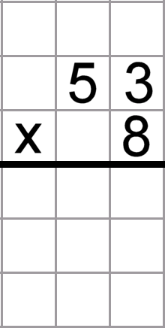

Make links with known tables to help children work out multiples of ten by single digit

|  |  |  |
| --- | --- | --- |
|  | 2 | 4 |
| 4 | 0 | 0 |

|  |  |  |
| --- | --- | --- |
| 4 | 2 | 4 |

**To do this, children must be able to:**

Partition numbers into tens and units

Multiply multiples of ten by a single digit (e.g. 50 x 8) using their knowledge of multiplication facts and place value

Recall and work out multiplication facts in the **2, 3, 4, 5, 8 and 10** times tables.

Work out multiplication facts not known by repeated addition or other taught mental strategies (e.g. by commutative law, working out near multiples and adjusting, using doubling etc.) Strategies to support this are repeated addition using a number line, bead bars and arrays (see Y2):

**Key vocabulary**: groups of, lots of, times, altogether, multiply, count, multiplied by, repeated addition, column, commutative, sets of, equal groups, times, _times as big as, once, twice, three times...,

**multiple, product, tens, units, value**

**Key skills for multiplication:**

* Recall and use multiplication facts for the **2, 3, 4, 5, 8 and 10** multiplication tables, and multiply multiples of 10.
* Write and calculate number statements using the multiplication tables they know, including **2-digit x single-digit**, drawing upon mental methods, and progressing to reliable written methods.
* Solve multiplication problems, including missing number problems.
* Develop mental strategies using commutativity (e.g. 4 x 12 x 5 = 4 x 5 x 12 = 20 x 12 = 240)
* Solve simple problems in contexts, deciding which operations and methods to use.
* Develop efficient mental methods to solve a range of problems e.g using commutativity (**4 × 12 × 5** = 4 × 5 × 12 **= 20 × 12** = 240) and for missing number problems _x 5 = 20, 3 x_ = 18, _x_ = 32

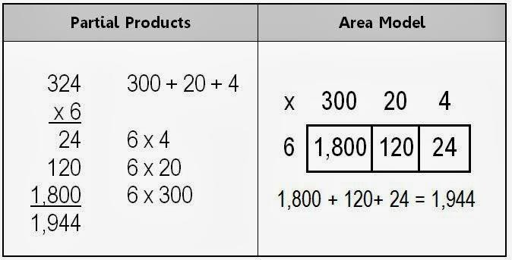

**Year 4 Multiply 2 and 3-digits by a single digit,** using all multiplication tables up to **12 x 12**

**Continue with the column method**

Continue with the column method introduce in year 3. Build upon this by using all multiplication tables and by introducing HTU x U as shown here.

Make links to work covered in year 3 (multiplying multiples of ten with a single digit number) to multiplying multiples of one hundred with a single digit number

This method can be used for TUxTU, decimals and larger numbers for more able children. BUT children should have been given lots of opportunities to use and apply these skills before moving on.

Move onto **short multiplication** (see Y5) if and when children are confident and accurate multiplying 2 and 3-digit numbers by a single digit this way,

Children should be able to:

* A**pproximate before they calculate**, and make this a regular part of their calculating, going back to the approximation to check the reasonableness of their answer. e.g:**―346 x 9** is approximately 350 x 10 = **3500‖**
* Record an approximation to check the final answer against. Multiply multiples of ten and one hundred by a single-digit, using their multiplication table knowledge.
* Recall all times tables **up to 12 x 12**

**Key vocabulary:** groups of, lots of, times, array, altogether, multiply, count, multiplied by, repeated addition, array, column, row, commutative, groups of, sets of, lots of, equal groups, times, multiply, times as big as, once, twice, three times... partition, grid method, total, multiple, product, sets of, **inverse**

**Key skills for multiplication at Y4:**

* Count in multiples of 6, 7, 9, 25 and 1000
* Recall multiplication facts for **all multiplication tables up to 12 x 12.**
* Recognise place value of digits in up to 4-digit numbers
* Use place value, known facts and derived facts to multiply mentally, e.g. multiply by 1, 10, 100, by 0, or to multiply 3 numbers.
* Use commutativity and other strategies mentally 3 x 6 = 6 x 3, 2 x 6 x 5 = 10 x 6, 39x7 = 30 x 7 + 9 x 7.
* Solve problems with increasingly complex multiplication in a range of contexts.
* Recognise the place value of each digit in a four-digit number (thousands, hundreds, tens, and ones)

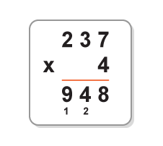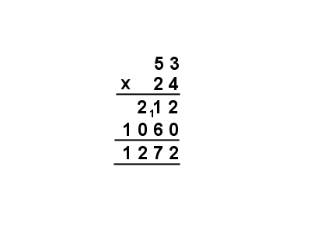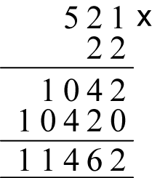

##### Year 5 Multiply up to 4-digits by 1 or 2 digits, begin to introduce decimals.

**Introducing short and long multiplication**

* + Introduce by comparing a column calculation to a short multiplication method, to see how the steps are related, but notice how there are less steps involved in short multiplication.
  + Children need to be taught to approximate first, e.g. for **72 x 38, they will use rounding: 72 x**

**38** is approximately 70 x 40 = **2800**, and use the approximation to check the reasonableness of their answer against.

x 300

4 1200

Short multiplication for multiplying by a single digit

Pupils could be asked to work out a given calculation using the column method, and then

|  |  |  |  |
| --- | --- | --- | --- |
|  |  | 2c0omp | ar7e it to |
|  |  | 8t0he s | te2p8s an |

„short multiplication. What are the similarities and differences? Unpick d show how it reduces the steps. Carry numbers underneath the answer

line, as with addition.

Introduce long multiplication for multiplying by 2 digits

Carry the 1 from the twelve (4x3) slightly under the first answer line

Ensure children understand that on second answer line it is 20 x 3 (or put the 0 in first)

Then move onto more complex numbers…

**Key vocabulary** groups of, lots of, times, array, altogether, multiply, count, multiplied by, repeated addition, column, row, commutative, sets of, equal groups, _times as big as, once, twice, three times, partition, grid method, total, multiple, product, inverse, **square, factor, integer, decimal, short/long, multiplication, carry**

**Key skills for multiplication at Y5:**

Identify multiples and factors, using knowledge of **multiplication tables to 12x12.**

Solve problems where larger numbers are decomposed into their factors Multiply and divide integers and decimals by 10, 100 and 1000

Recognise and use square and cube numbers and their notation

Solve problems involving combinations of operations, choosing and using calculations and methods appropriately.

**Year 1 Group and share small quantities**

Using objects, diagrams and pictorial representations to solve problems involving **both grouping and sharing**.

12÷4 = Ask……..How many groups of 4 can be made with 12 stars? **= 3**

**Grouping:**

**Sharing:**

If we share 12 stars between 4 groups, how many will be in each? = 3

**Example division problem in a familiar context:**

There are 6 pupils on this table and there are 18 pieces of fruit to share between us. If we share them equally, how many will we each get?

Can they work it out and give

a division statement… ?

“18 shared between 6 people gives you 3 each.”

**Pupils should:**

* use lots of practical apparatus, arrays and picture representations
* Be taught to understand the difference between „grouping objects (How many groups of 2 can you make?) and „sharing (Share these sweets between 2 people)
* Be able to count in multiples of 2s, 5s and 10s.
* Find **half** of a group of objects by sharing into 2 equal groups.

|  |  |
| --- | --- |
|  |  |
| **Key Vocabulary: share, share equally, one each, two each…, group, groups of, lots of, array**  **Key number skills needed for division at Y1:**   * Solve one-step problems involving multiplication and division, by calculating the answer using concrete objects, pictorial representations arrays with the support of the teacher * Through grouping and sharing small quantities, pupils begin to understand, division, and finding simple fractions of objects, numbers and quantities. * They make connections between arrays, number patterns, and counting in twos, fives and tens. |  |
|  |  |

**Year 2 Group and share, using the ÷ and = sign**

Use objects, arrays, diagrams and pictorial representations, and grouping on a number line.

**Arrays:** This represents **12 ÷ 3, posed as**

how many groups of 3 are in 12?

Pupils should also show that the same array can represent **12 ÷ 4 = 3** if grouped horizontally

**Know and understand sharing and grouping:**

Grouping

Sharing

Children should be taught to recognise whether problems require sharing or grouping.

##### Grouping using a number line:

Count number of jumps to find answer

Do not include the +4 if it is going to confuse children. Begin on a marked numberline

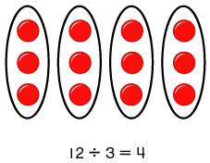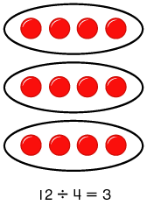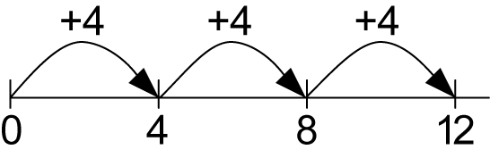

Group from zero in equal jumps of the divisor to find out how many groups of _ in _ ?. Pupils could and using a bead string or practical apparatus to work out problems like A CD costs £3. How many CDs can I buy with £12? **This is an important method to develop understanding of division as grouping.**

Pose 12 ÷ 4 as „How many groups of 4 are in 12

**Key Vocabulary: share, share equally, one each, two each…, group, equal groups of, lots of,**

**array, divide, divided by, divided into, division, grouping, number line, left, left over**

**Key number skills needed for division at Y2:**

* Count in steps of 2, 3, and 5 from 0
* Recall and use multiplication and division facts for the **2, 5 and 10** multiplication tables, including recognising odd and even numbers.
* Calculate mathematical statements for multiplication and division within the multiplication tables and write them using the x, **÷** and = signs.
* Show that multiplication of two numbers can be done in any order (commutative) and division of one number by another cannot.
* Solve problems involving multiplication and division, using materials, arrays, repeated addition, mental methods, and multiplication and division facts, including problems in contexts.

##### Year 3 Divide 2-digit numbers by a single digit (where there is no remainder in the final answer)

Grouping on a number line: **STEP 1: Children continue to work out unknown division**

**facts by grouping on a number line from zero.** They are also

**4 r 1** nnooww ttaauugghhtt tthhee ccoonncceepptt ooff r**r**e**e**m**m**a**a**i**i**n**n**d**d**e**e**r**r**s**s,**usaisnginththisemeextahmopdle. This

s

**r 1**

hould be introduced practically and with arrays, as well as

ng translated to a number line. Children should work wards calculating some basic division facts with remainders

ntally for the 2s, 3s, 4s, 5s, 8s and 10s, ready for „carrying‟

ainders across within the short division method.

+1 bei

+3 +3 +3 +3

to

me

13 ÷ 4 = 3 r 1

This could be introduced practically or with arrays as well as being translated to a number line. Children should work on

rem calculating some basic division facts with remainders mentally for their known tables to prepare them for ‘carrying’ remainders

13

when they begin short division.

Real life contexts need to be used routinely to help pupils gain a full understand- ing, and the ability to recognise the place of division and how to apply it to problems.

Short division: Limit numbers to **NO** remainders in the answer **OR** carried (each digit must be a multiple of the divisor).

### 32

3 96

Short division: Limit numbers to **NO** remainders in the final answer, but with remainders occurring within the calculation (carried).

**STEP 2:** Once children are secure with division as grouping and demonstrate this using number lines, arrays etc., **short division** for larger 2-digit numbers should be introduced, initially with carefully selected examples requiring no calculating of remainders at all. Start by introducing the layout of short division by comparing it to an array.

**Remind children of correct place value, that 96 is equal to 90 and 6, but in short division, pose:**

* How many 3‟s in 9? = 3, and record it above the **9 tens**.
* How many 3‟s in 6? = 2, and record it above the **6 units**.

**STEP 3:** Once children demonstrate a full understanding of remainders, and also the short division method taught, they can be taught how to use the method when remainders occur within the calculation (e.g. 96†8), and be taught to carry the remainder onto the next digit. **If needed, children should use the number line to work out individual division facts that**

**occur which they are not yet able to recall mentally.**

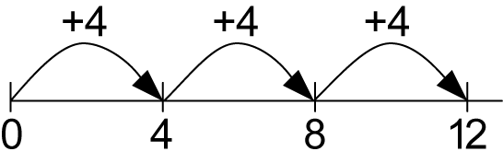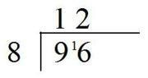

**Key Vocabulary:** share, share equally, one each, two each…, group, equal groups of, lots of, array, divide, divided by, divided into, division, grouping, number line, left, left over, **inverse, short division, ‗carry, remainder, multiple**

**Key number skills needed for division at Y3:**

* Recall and use multiplication and division facts for the 2, 3, 4, 5, 8 and 10 multiplication tables (through dou- bling, connect the 2, 4 and 8s).
* Write and calculate mathematical statements for multiplication and division using the multiplication tables that they know, including for two-digit numbers times one-digit numbers, using mental and progressing to for-

mal written methods.

* Solve problems, in contexts, and including missing number problems, involving multiplication and division.
* Pupils develop efficient mental methods, for example, using multiplication and division facts (e.g. using 3 × 2 = 6, 6 ÷ 3 = 2 and 2 = 6 ÷ 3) to derive related facts (30 × 2 = 60, so 60 ÷ 3 = 20 and 20 = 60 ÷ 3).
* Pupils develop reliable written methods for division, starting with calculations of 2-digit numbers by 1-digit numbers and progressing to the formal written method of short division.

##### Year 4 Divide up to 3-digit numbers by a single digit

(without remainders initially)

**Continue to develop short division:**

Short division should only be taught once children have secured the skill of calculating „remainders‟.

**STEP 1**: Pupils must be secure with the process of short division for dividing 2-digit numbers by a single digit (**those that do not result in a final remainder**

—see steps in Y3), but must understand how to calculate remainders, using this to „carry‟ remainders within the calculation process (see example).

Real life contexts need to be used routinely to help pupils gain a full understand- ing, and the ability to recognise

321

3 963

**STEP 2**: Pupils move onto dividing numbers with up to **3-digits** by a single digit, however problems and calculations provided should **not result in a final answer with remainder** at this stage**.** Children who exceed this expectation may progress to Y5 level.

When the answer for the **first column** is zero (1 ÷ 5, as in example), children could initially

the place of

division and how to apply it to problems.

write a zero above to acknowledge its place, and must always „carry‟ the number (1) over to the next digit as a remainder.

Include money and measure contexts when confident.

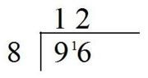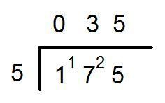

**Key Vocabulary:** share, share equally, one each, two each…, group, equal groups of, lots of, array, divide, divided by, divided into, division, grouping, number line, left, left over, inverse, short division, „carry‟, remainder, multiple, **divisible by, factor**

**Key number skills needed for division at Y4:**

* + **Recall multiplication and division facts for all numbers up to 12 x 12.**
  + Use place value, known and derived facts to multiply and divide mentally, including: multiplying and dividing by 10 and 100 and 1.
  + Pupils practise to become fluent in the formal written method of short division with exact answers when dividing by a one-digit number
  + Pupils practise mental methods and extend this to three-digit numbers to derive facts, for example 200

× 3 = 600 so 600 ÷ 3 = 200

* + Pupils solve two-step problems in contexts, choosing the appropriate operation, working with increasingly harder numbers. This should include correspondence questions such as three cakes shared equally between 10 children.

**Year 5 Divide up to 4 digits by a single digit,** including those with remainders.

Short division, including remainder answers:

**Short division with remainders:** Now that pupils are introduced to examples that give rise to remainder answers, division needs to have a real life problem solving context, where **pupils consider the meaning of the remainder and how to express it,** ie. as a fraction, a decimal, or as a rounded number or value , depending upon the context of the problem.

The answer to 847 ÷ 5 could be expressed as 169 and two fifths, 169 r 2, as a decimal, or rounded as appropriate to the problem involved.

Include money and measure contexts.

See Mrs Mullick for how to continue the short division to give a decimal answer for children who are more able and ready to do this.

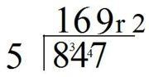

**Key Vocabulary:** share, share equally, one each, two each…, group, equal groups of, lots of, array, divide, divided by, divided into, division, grouping, number line, left, left over, inverse, short division, carry, remainder, multiple, divisible by, factor, inverse, **quotient, prime number, prime factors, composite number (non-prime)**

Key number skills needed for division at Y5:

* + Recall multiplication and division facts for all numbers up to 12 x 12 (as in Y4).
  + Multiply and divide numbers mentally, drawing upon known facts.
  + Identify multiples and factors, including finding all factor pairs of a number, and common factors of two number.
  + Solve problems involving multiplication and division where larger numbers are decomposed into their factors.
  + Multiply and divide whole numbers and those involving decimals by 10, 100 and 1000.
  + Use the vocabulary of prime numbers, prime factors and composite (non-prime) numbers.
  + Work out whether a number up to 100 is prime, and recall prime numbers to 19.
  + Divide numbers up to 4 digits by a one-digit number using the formal written method of short division and inter- pret remainders appropriately for the context
  + Use multiplication and division as inverses.
  + Interpret non-integer answers to division by expressing results in different ways according to the context, includ- ing with remainders, as fractions, as decimals or by rounding (e.g. 98 ÷ 4 = 24 r 2 = 241/2 = 24.5 ≈ 25).
  + Solve problems involving combinations of all four operations, including understanding of the equals sign, and includ- ing division for scaling by different fractions and problems involving simple rates.

**Monitoring and Review**

This policy was reviewed and agreed by the Governing Body. We are aware of the need to review the Calculation Policy regularly. The Policy will be formally reviewed by the Teaching and Learning Committee every 2 to 3 years.

**Date of last review: Autumn 2015**

**Date of next review: Summer 2018**