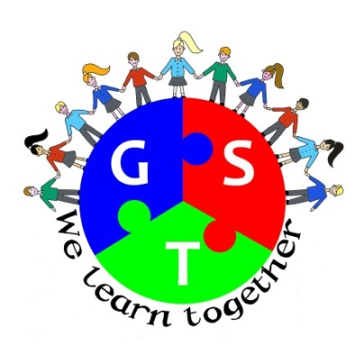

**Gosforth Schools Trust**

**Summer Term 2015 Newsletter**

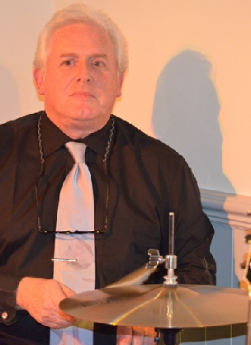

**Welcome from the Chairman**

Friends, the Gosforth Schools’ Trust has now been operational for just over a year. As you will see from the other articles in this newsletter there has been a lot going on which would not have happened without our new collaborative approach. For the Directors, this has been a year of learning as we discover more about this new form of Governance and the real implications of our new responsibilities. However I am very pleased to note that the real good news stories from this year are all about the children and the wonderful variety of activities offered in our schools. I am also very impressed with the way in which the Trust Schools Council is embracing its role and is starting to feed ideas to the Board. I am looking forward to some lively meetings in the next school year.

Good luck to all of our year 8 leavers who are moving on to new schools. I hope everyone enjoys a good summer break and returns refreshed in September.

**Hello from our Business Manager**

Well the summer is eventually here but as I’m writing this the weather is very inclement – here’s hoping that the sun comes out for the various end of term events planned across all our schools and remains with us throughout the seven week summer holiday.

The Gosforth Schools Trust Board has been involved in discussions about the need for additional places in some of our schools. The planned expansion at [**Grange First School**](http://www.grange.newcastle.sch.uk/website)[**, Brunton First School**](http://www.bruntonfirst.newcastle.sch.uk/website) and[**South Gosforth First School**](http://www.southgosforth.newcastle.sch.uk/website) will begin in earnest. By September these schools will have increased their intake by 90 places. The Local Authority is aware that even more places will be needed in the future and the Gosforth Trust is working in partnership with the LA to try and find a solution for the growing demand for school laces in Gosforth. We will try to keep everyone informed of any decisions and developments as they happen.

We are striving to improve our communications across the Trust area and with all of our stakeholders. Our website is live and you can visit it by clicking [**here**](http://www.gosforthschoolstrust.co.uk/website/home/86292)**.** We are keen to hear your views on it – why not drop me an [email](mailto:julie.mcmanus@gosforthcent.newcastle.sch.uk) and let me know what you think?

We are also on Twitter why not follow us on @GosforthGST and keep up to date with the activities and achievements of our pupils and staff?

Kind Regards

**Julie McManus MA –** Business Manager Gosforth Schools’ Trust

**Trust News**

There are many exciting things going on in all of our schools and these can be seen on schools’ individual websites and through newsletters from each school. You can access school websites via the trust website. As well as all of the hard work and the success stories at each individual school, we are working together to ensure that we get the very best for the pupils of the Trust. Below is some information about some of the early successes which we have enjoyed by working as a Trust, we hope that you enjoy reading about some of these and we wish everyone a great summer holiday!

**500Games**

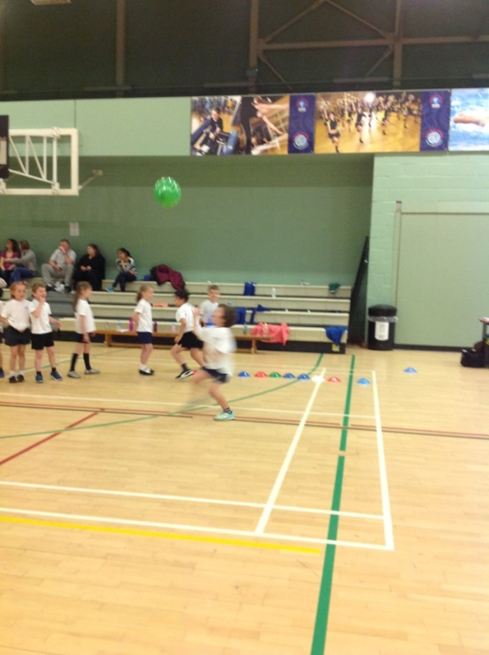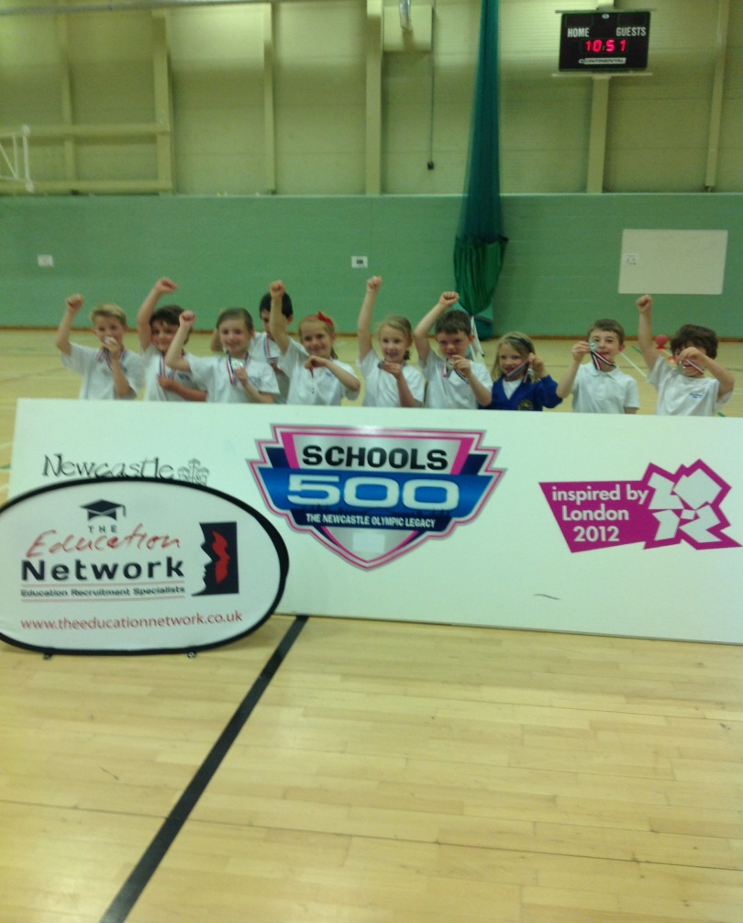The nine first schools in the Trust have shared a specialist PE teacher for 2 years. Her role has been to increase participation in PE and school sport as well as having a sustainable and positive difference to teachers’ skills. As well as working with a specialist teacher we have all increased our participation in competition and sporting events in that time. This year almost all of our schools in the Gosforth Schools’ Trust took part in Newcastle’s 500 Games. The 500 Games are organized by Newcastle PE and School Sport Service as part of the Olympic Legacy, there are many events and individual schools can choose which events to attend. Between groups of schools this year we were able to plan events together, travel together and share travel expenses so that we could afford to take part in more events. The competition is high and the children love the challenge and the fun of competing with neighbouring schools in Gosforth and across the city. Between us we brought home lots of medals in Key Stage 1 and Key Stage 2 events and we are all looking forward to competing again next year.

**The Get Active Great Outdoors Summer Challenge**

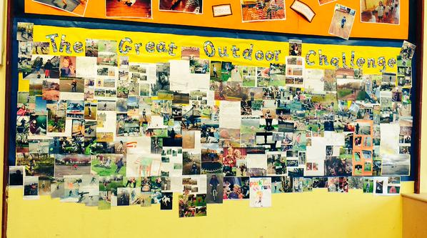During the past two terms, the PE subject leaders from each school in the GST have been meeting to share expertise and plan provision in individual schools and across the Trust. One of the outcomes from this group was the Get Active Great Outdoors Summer Challenge in which 8 schools took part. We wanted to encourage the families in our schools to have some screen-free time and get outdoors to enjoy lots of different activities. We gave each child a list of suggestions which ranged from building a den to going for a family bike ride. The initiative was a great success with many children and families trying something new and feeling the benefits of being active. The challenge lasted for six weeks during which time children brought pictures and writing to school, or in some cases ‘tweeted’ pictures of their activities. Each school then chose 5 representatives to attend a celebration event at Broadway East First School. This was an afternoon of multiskills activities and then a celebration assembly during which all the children received a GST sports bag full of goodies. Chloe Fletcher from Newcastle PE and Sport Service came along to talk to the children about being active and the benefits of having a healthy lifestyle. We are already planning how we can make the 6 weeks of activity more sustainable and encourage even more families to get involved next year.

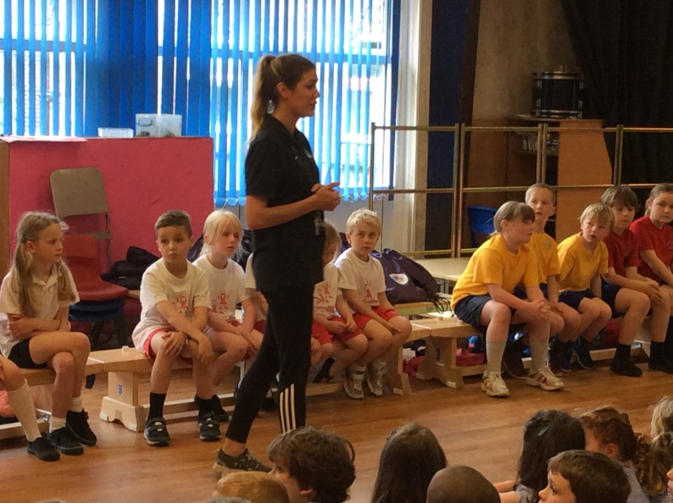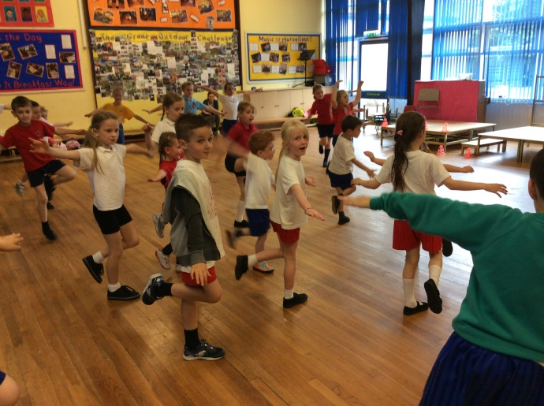

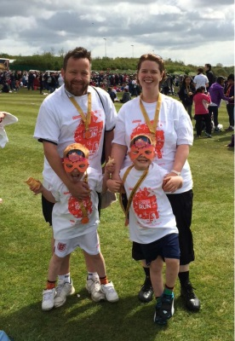

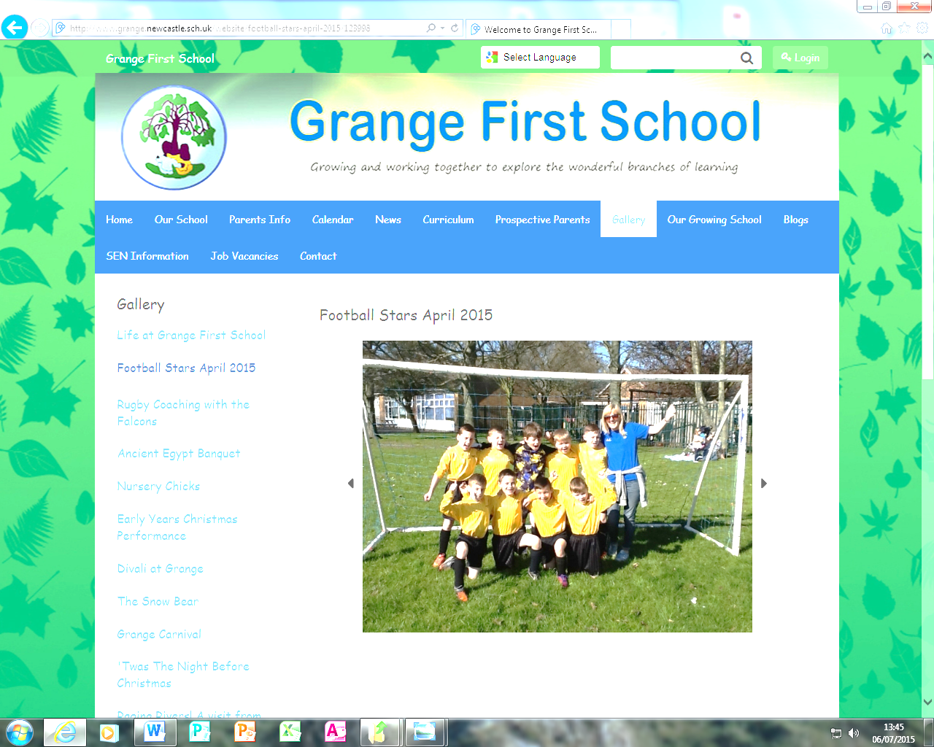**The Gosforth Cup**

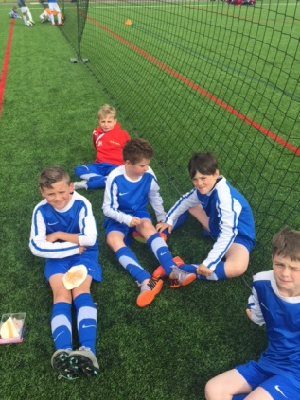Working with Lee Sterry Sports we have now set up an annual tournament, the Gosforth Cup. All first schools in the GST, and both catholic primary schools in Gosforth, are invited to take part and enter up to two teams each. This year there was a record number of teams taking part and an exciting atmosphere as a few schools had some old scores to settle! It was a great day and we intend to build on this success next year with more tournaments and a possible GST league.

**The Pyramid and Trust Concerts**

Gosforth Voices, Gosforth Band and Intermediate Voices are groups of pupils from across the GST schools who meet monthly to sing and perform together. Newcastle Music Service support this work across the schools and get some amazing results from our pupils. In May we had a concert at Gosforth East Middle School where all three groups gave us an evening of entertainment and wonderful music. In June there was another chance to perform again at Newcastle City Hall when we joined the Academy to lift the roof and showcase pupils’ talents from Year 3 to Sixth Form. Children performed in varied ensembles including the Pyramid Wind Band, Grand Ceilidh Band, Pyramid String Ensemble and the Combined Choir. Gosforth Voices, Intermediate Voices and Gosforth Band also performed beautifully, for many of the youngest performers it was the first opportunity to perform in such a large venue to a packed auditorium. Each ensemble included performances of songs composed by North Eastern song writers, highlighting the contribution of this region to the music industry.

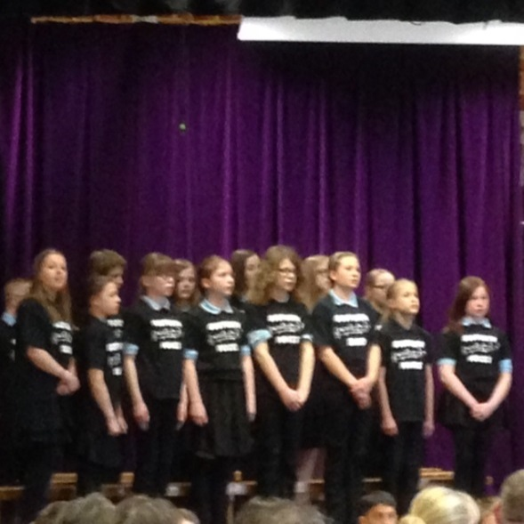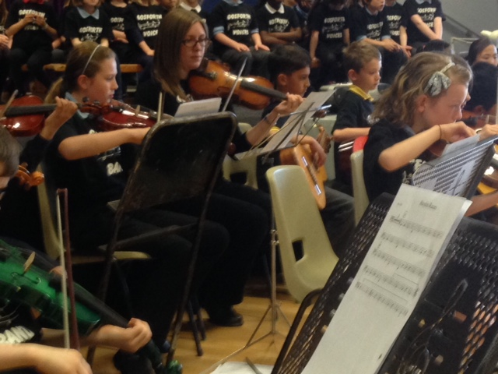

**Transition Projects**

The first school children who will be attending Gosforth Central Middle School in September have joined together to create a joint topic based on the Romans. This has been designed by staff so that children can have the smoothest possible transition to the next phase of their education and make new friends with children from neighbouring schools before September. They have visited Vindolanda together and worked in school towards agreed aims form the new National Curriculum. Joint writing books have allowed teachers to compare and moderate writing standards and ensure continuity in achievement for all the children. Other first schools have also built on their usual transition arrangements which included a series of visits with various themes and close collaboration between staff. This year groups of staff have met to moderate samples of children’s work across the GST, starting with Early Years and working up, so that we all have an agreed understanding of achievement.

**GST School Council**

Many thanks to all the children from our trust schools that attended the recent Trust Pupil Council meeting hosted by Gosforth Central Middle School. We decided to give our younger pupils a bit of experience of what middle school was like, so we started the afternoon with lunch and some break time on the field. The afternoon was spent exploring communication through some games and we concluded the session by creating and voting for our trust council values. Thank you to Archibald First School for offering to host the next meeting; we look forward to seeing you there!