Significant People involved in the Great Fire of London
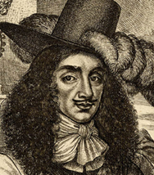
Thomas Farriner
Thomas Farriner was a baker in 17th Century London. He owned a bakery on Pudding Lane where the Great Fire of London is believed to have started. It is believed that the fire in Thomas Farriner’s bakery was not put out properly and a spark from the flame started the fire. Thomas Farriner and his family escaped the fire by climbing out of an upstairs window, unfortunately his maid died in the fire.
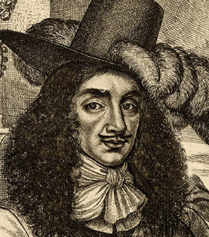
Thomas Bludworth

Bludworth was Lord Mayor of London at the time of the fire. Evidence suggests that Bludworth did not take the fire seriously and did not order anyone to start putting put the fire, many people believe that he thought the fire would go out by itself. There is also evidence that Mayor Bludworth left London the day after the fire started and did not return for 3 days. When the fire first broke out there was a meeting in London to discuss how to deal with it. Thomas Bludworth did not attend the meeting.
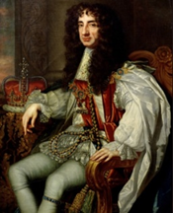
King Charles II

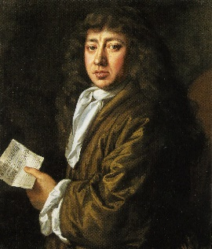
King Charles II was King of England and Scotland at the time of the Great Fire of London. He helped the people fighting the fire, gave rewards to people who tried to stop the fire, and helped people who were hungry and homeless after the fire was over. However, 5 years before the fire started the King had been warned that the way the houses in London were built would mean that if a fire ever broke out it would be a disaster!
Samuel Pepys

Samuel Pepys is most famous for keeping a diary for most of the 1660s, so he wrote a lot about the Great Fire in 1666. He also played an important part in helping to fight the fire by warning King Charles II that more needed to be done on the day the fire broke. His diaries are one of the main reasons that we know so much about the fire today.

