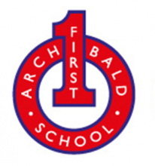
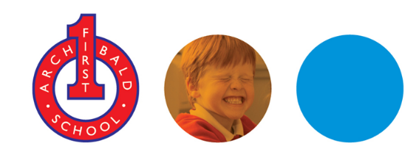
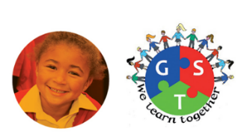
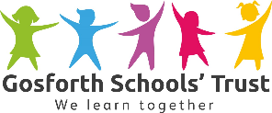

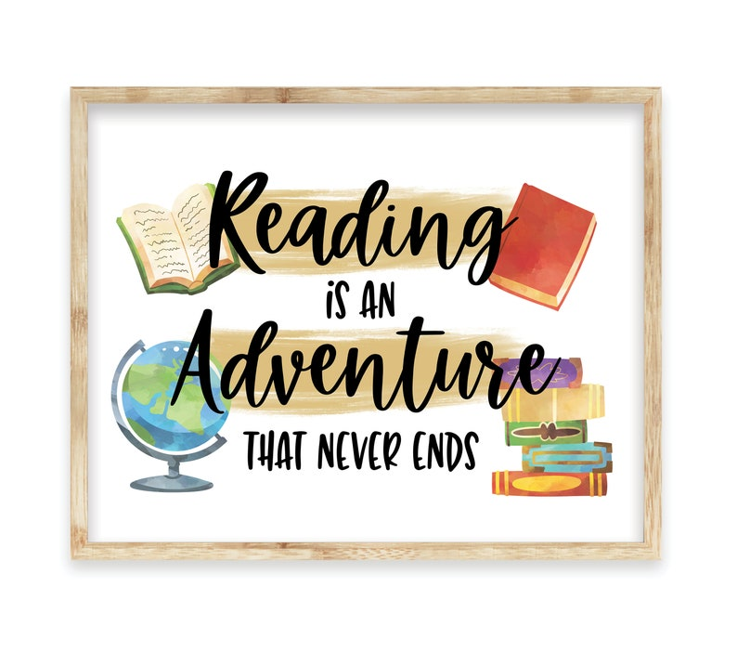
Archibald Reading Lists
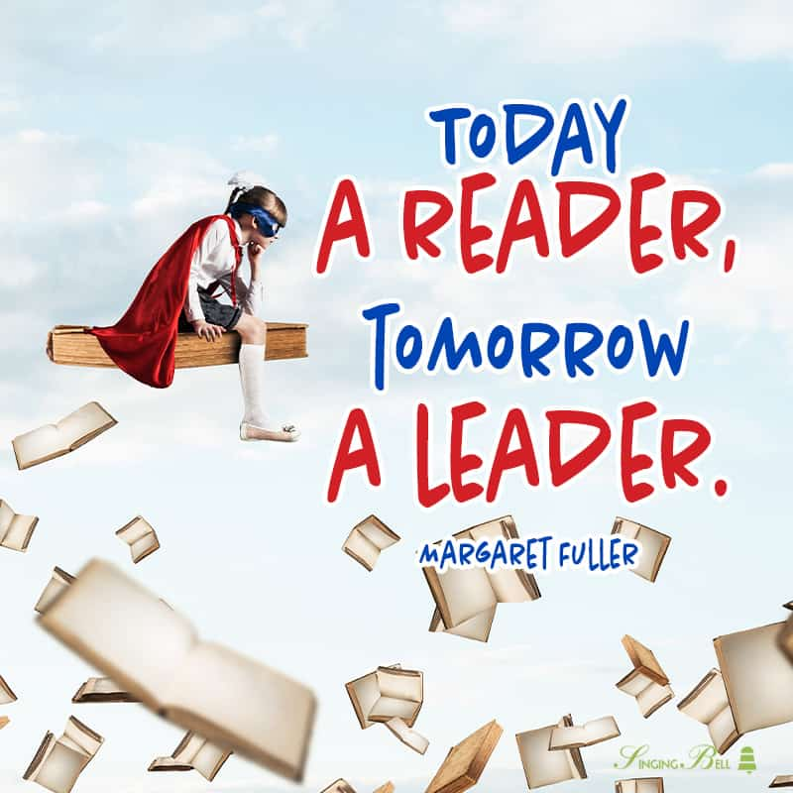

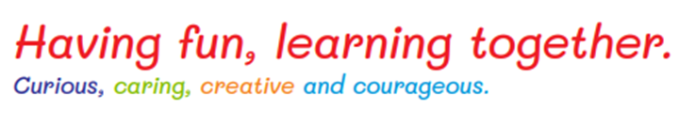
Nursery
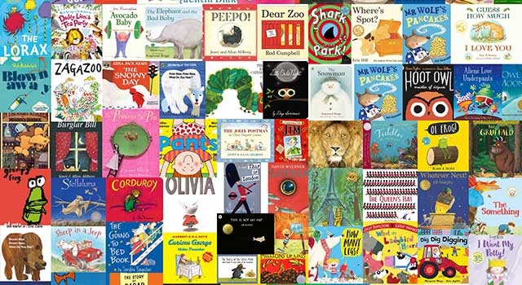
There are lots of choices with reading ideas to suit all abilities, with a wide variety of suggested picture books, emerging reader books, and first chapter books for 4-year-olds, 5-year-olds, 6-year-olds, and 7-year-olds in primary schools. These stories include texts to encourage shared reading, individual reading, reading aloud, and reading for pleasure. There are plenty of picture books to share and inspire a love of independent reading, and for reading with parents at home. This is a pivotal time in your child’s education. We hope you find some great books that will inspire, challenge, enthuse and entice and above all, spark a love of reading and thirst for knowledge and understanding.

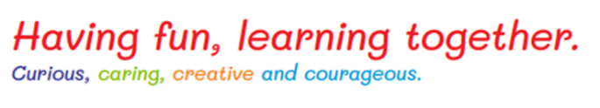
100 picture books for EYFS to read before you are 5 years old
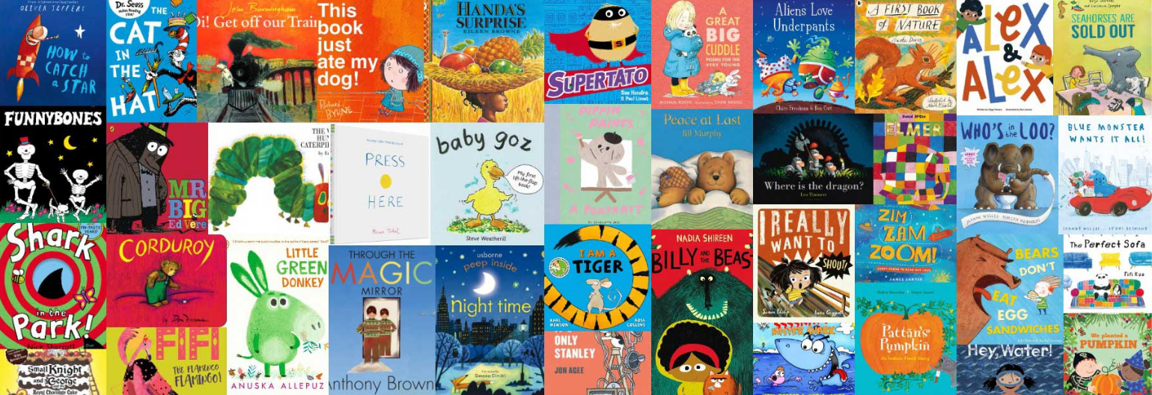
Reception
Rrrrr

40 books to read in Reception
Year 1
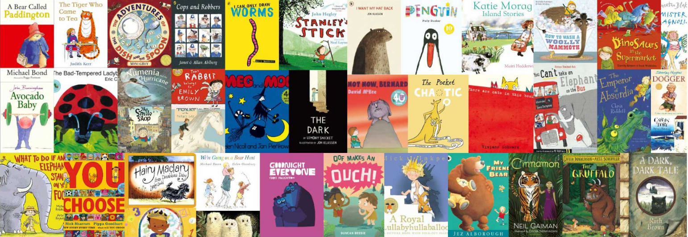

40 books to read in Year 1
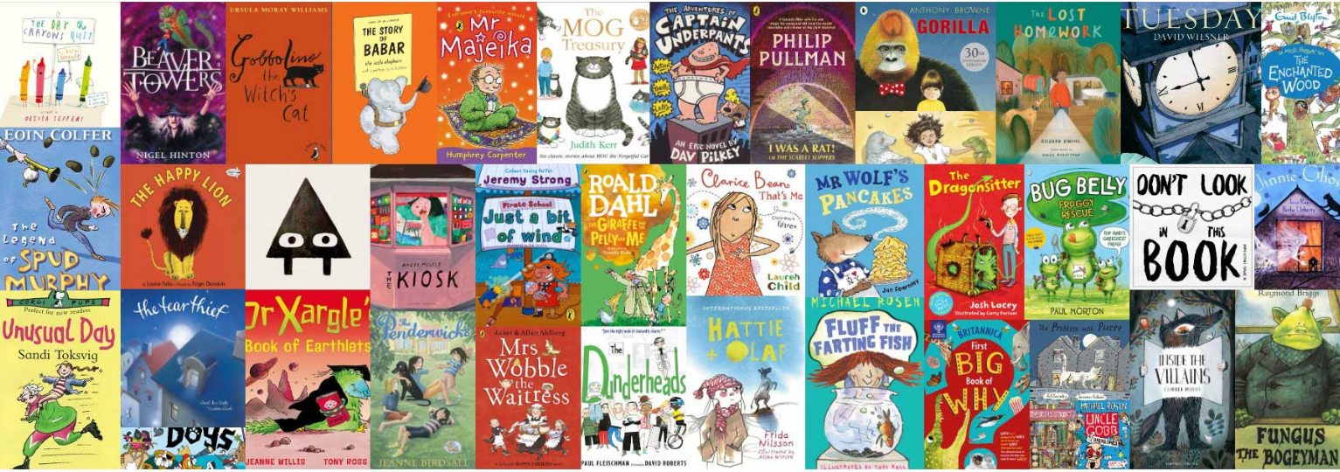
Year 2

40 books to read in Year 2
Year 3
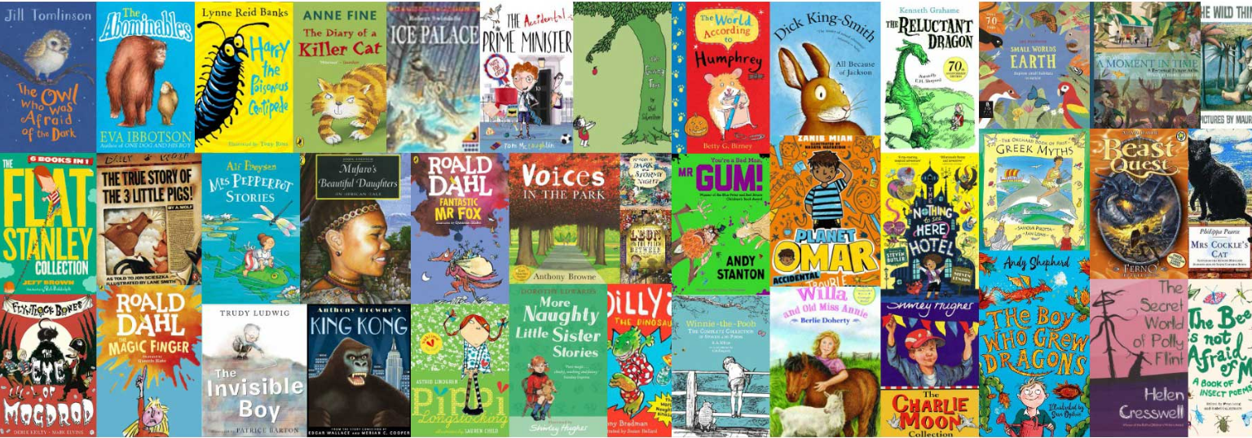
As children move to Key Stage 2, they become more fluent, independent readers. With mystery books, adventure stories, myths and legends, biographies, graphic novels, funny stories and fantasy reading, there really is a genre for everyone! The suggested reading books for Year 3 and Year 4 pupils, aged 7-9, include a diverse and interesting range of exciting titles aimed at children of all abilities to enjoy.

40 books to read in Year 3
Year 4
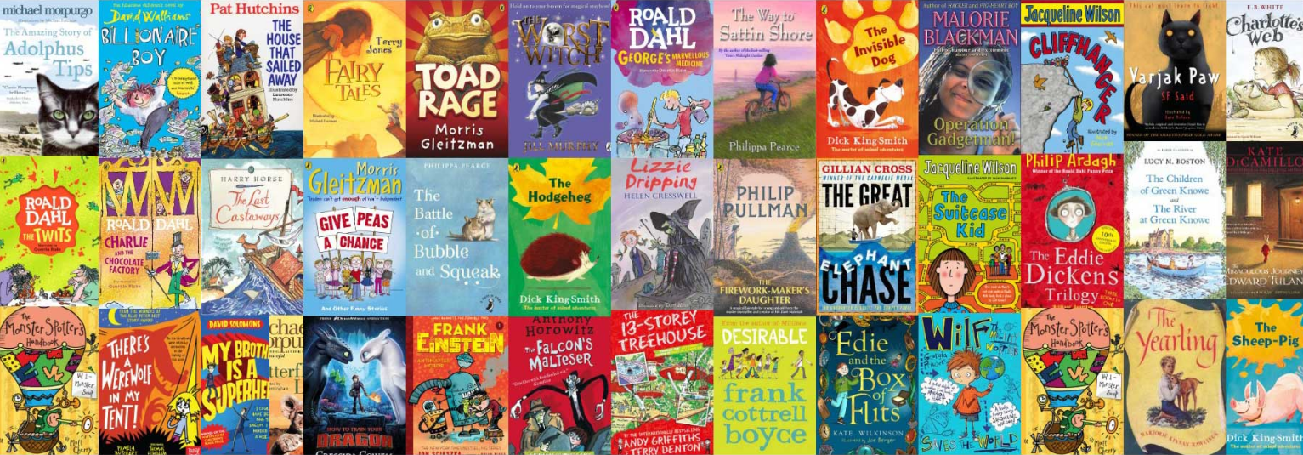

40 books to read in Year 4

